DOUTSo

1)

Class name is not In uppercase but running (violating case sensitive)

2)while declaring class as public class and file name should be same if not throwing error if we did not declare class as public then the class and file name might be different

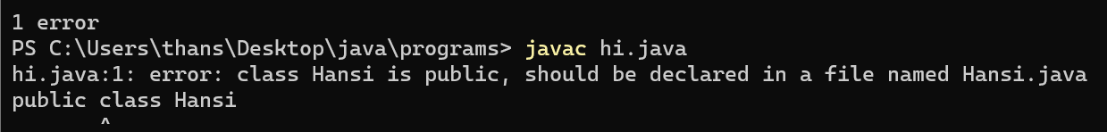

3) The size of a primitive type depends on the data type, while non-primitive types have all the same size

Does it mean like if byte range is from -128 to 127 but size of arrays might be of our own size

4)

HOW TO PRINT MULTIPLE VARIABLE IN SINGLE PRINT STATEMENT??

5)dout in type casting(narrowing casting) of having more than6-7 decimals and converting to float(program as main)

6)douts in operators from &

7)difference between newline(\n) and carriage return(\r)

8)how to take character as input and in userinput.java error dout

9)in overloading.java in case 1 I need to 2 input and in case 2 I need to take 3 input in which two are of in case1 in such a case how I should

Imp:

If I use 2 parameters in one method and 3 pararmeters in other method then if pass 2 arguments then both 2 methods are executing

9)in overwring.java overwriting is not allowing

10)in overriding.java overriding is not allowing

DOUTSn

1)goto isn’t there in java